Fundamentals of Computer Programming

Building a Programming Portfolio

Week 3

You should be able to complete the following programs by the end of the week. You should

keep the code somewhere safe, in an organized way. GitHub is ideal. Wherever you choose,

you should ensure that the work is safe and backed up.

Possible solutions will be uploaded to the main module GitHub repository every week. If you

follow that repo you should be able to receive notifications

1. Modify your greeting program so that if the user does not enter a name (i.e. they just press enter), the program responds "Hello, Stranger!". Otherwise it should print a greeting with their name as before.

→ Here is the output

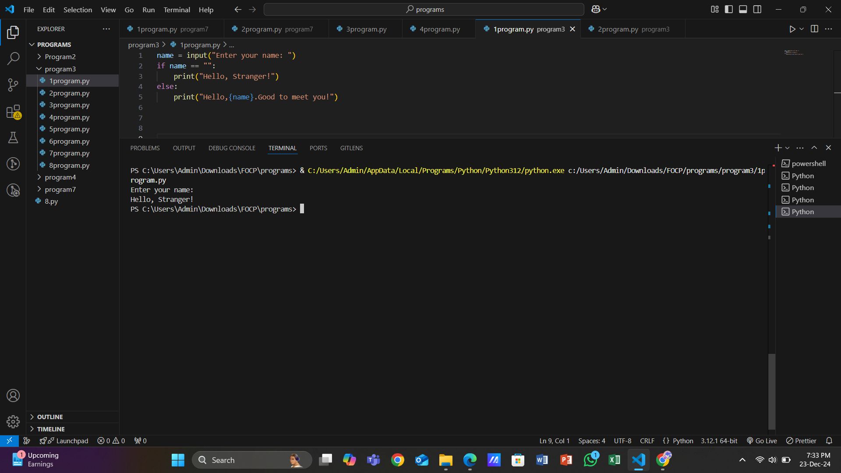

1. Write a program that simulates the way in which a user might choose a password. The program should prompt for a new password, and then prompt again. If the two passwords entered are the same the program should say "Password Set" or similar, otherwise it should report an error.

→ Here is the output

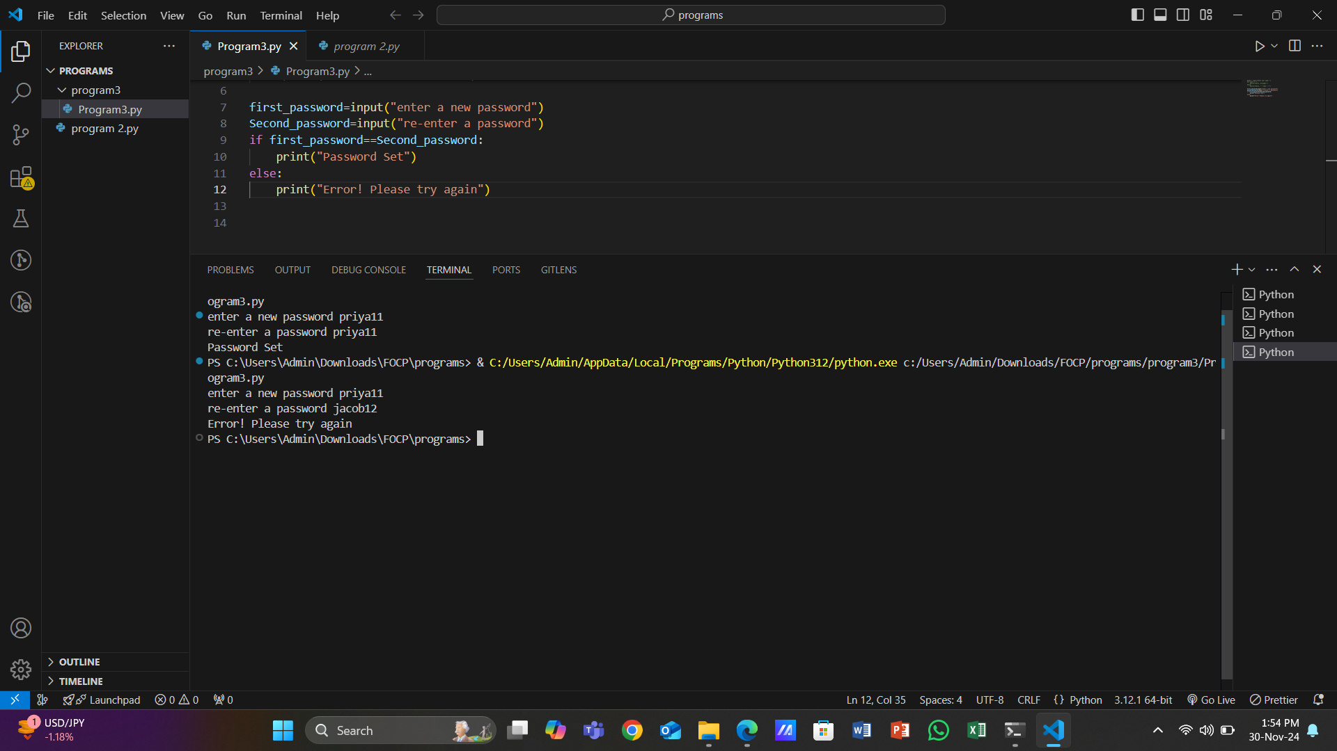

1. Modify your previous program so that the password must be between 8 and 12 characters (inclusive) long

→ Here is the output

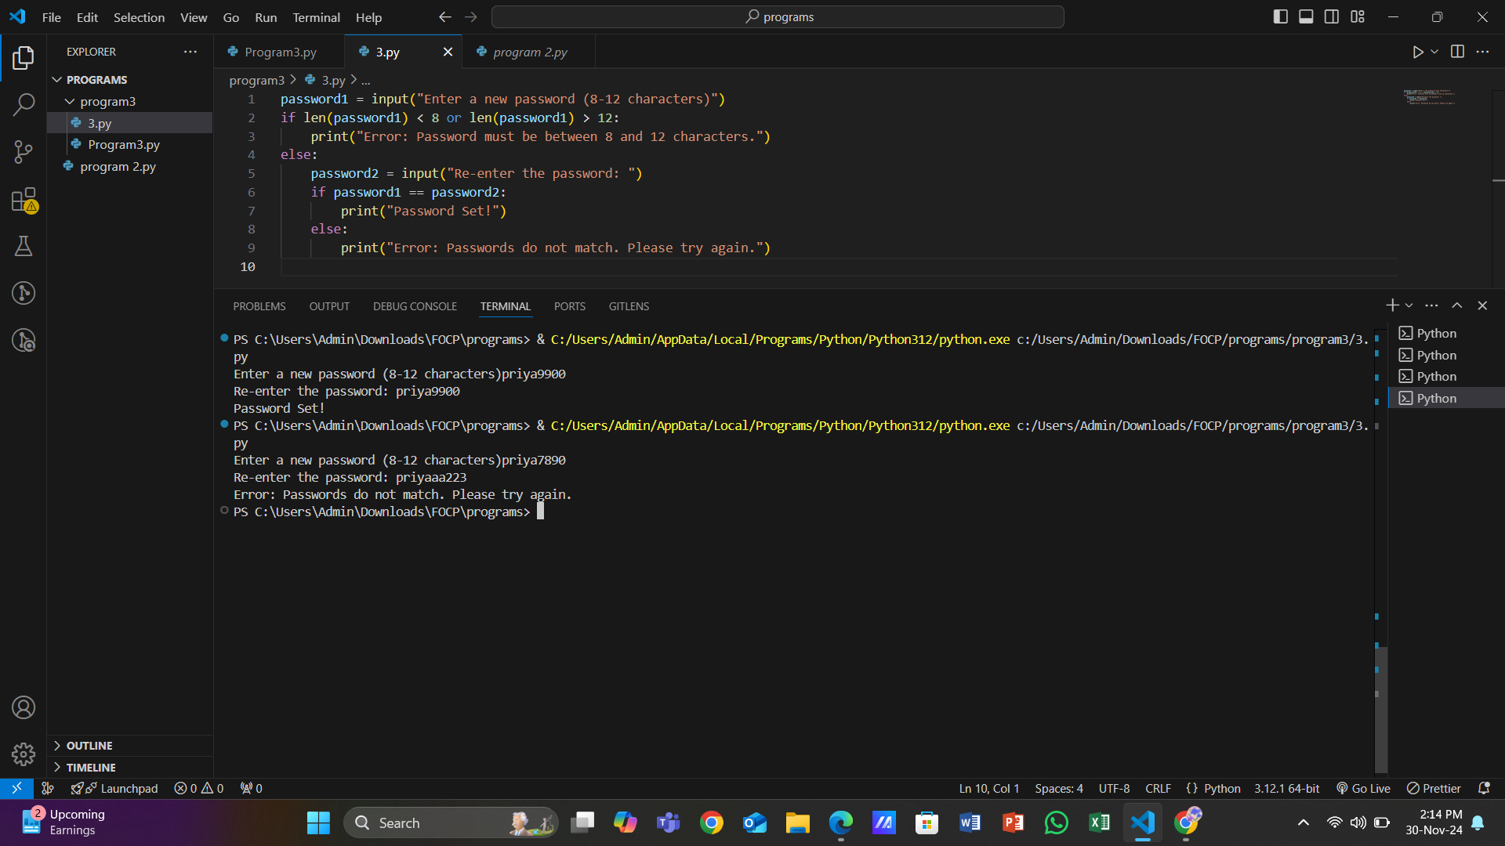

1. Modify your program again so that the chosen password cannot be one of a list of common passwords, defined thus: BAD_PASSWORDS = ['password', 'letmein', 'sesame', 'hello', 'justinbieber']

→ Here is the output

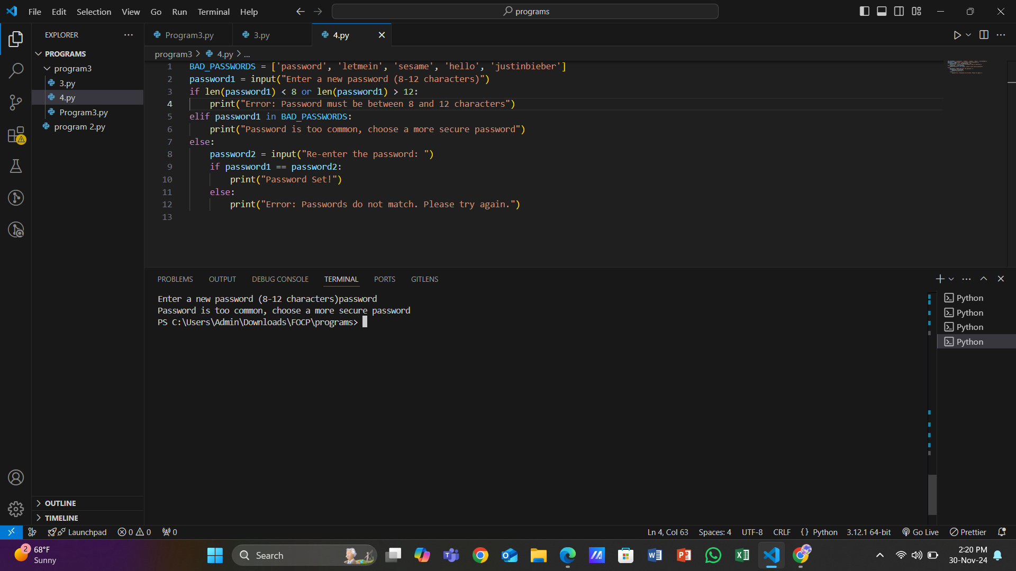

5. Modify your program a final time so that it executes until the user successfully chooses a password. That is, if the password chosen fails any of the checks, the program should return to asking for the password the first time.

→ Here is the output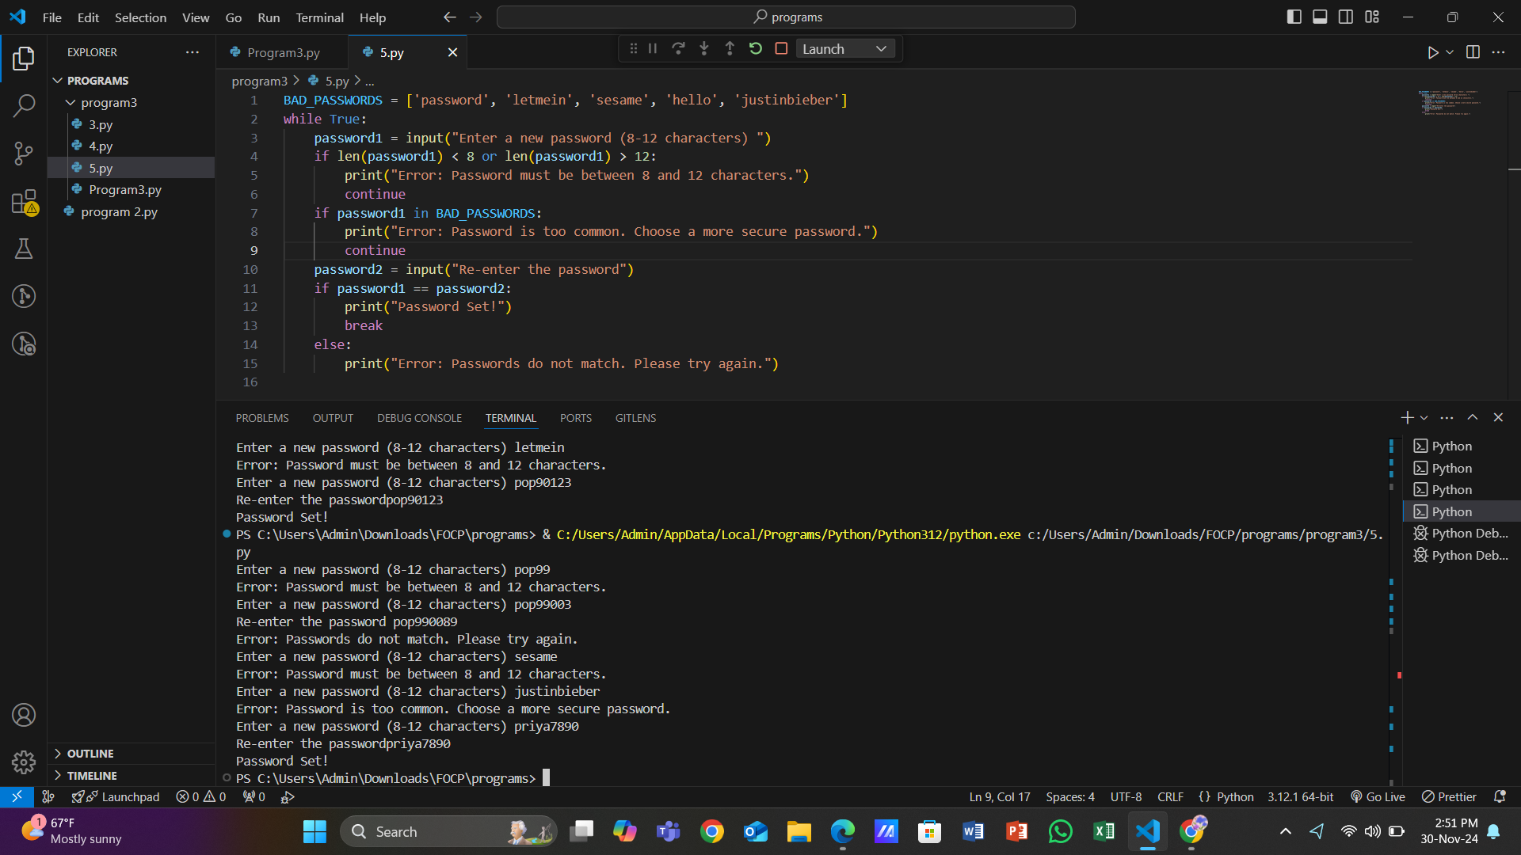

6. Write a program that displays the "Seven Times Table". That is, the result of multiplying 7 by every number from 0 to 12 inclusive. The output might start:

0 x 7 = 0

1 x 7 = 7

2 x 7 = 14

and so on.

→ Here is the output

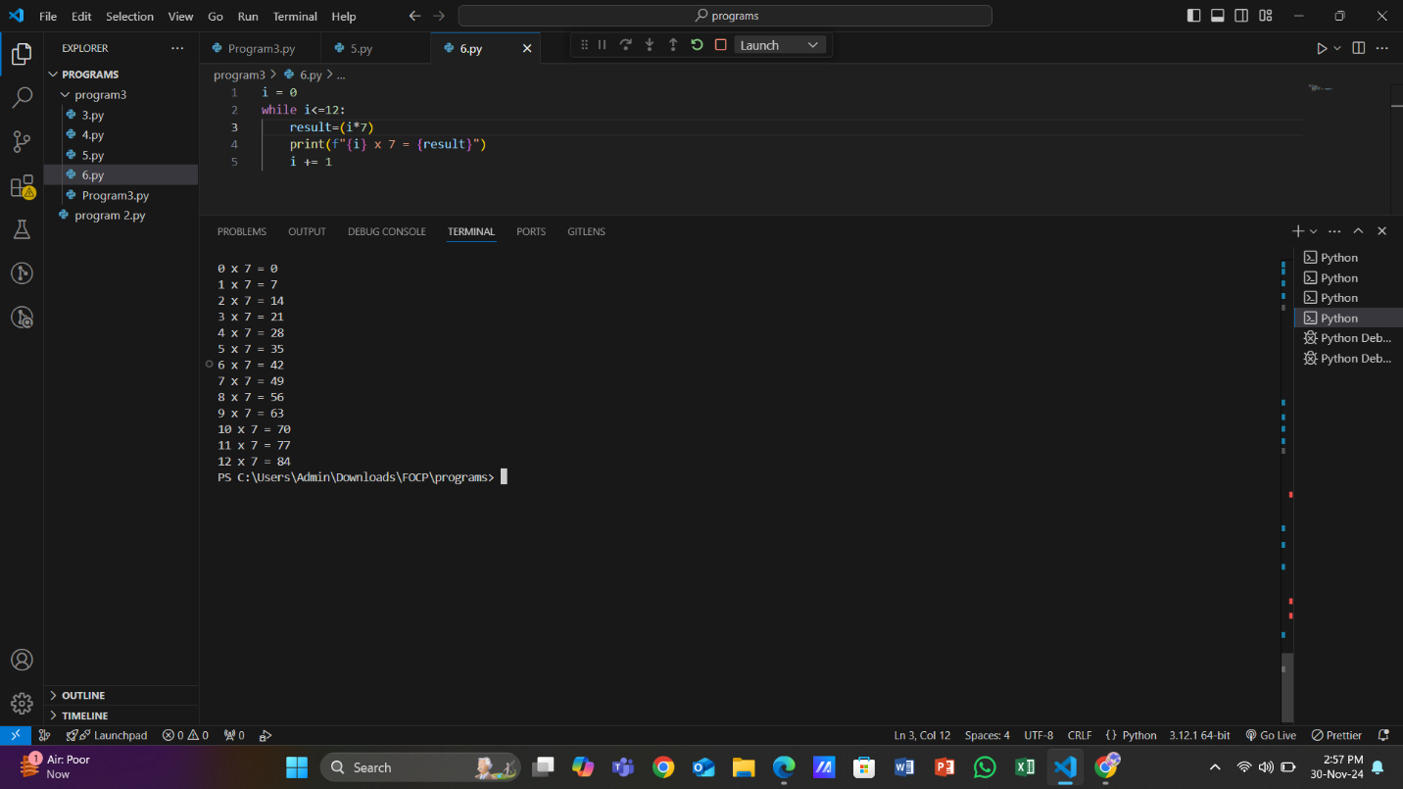

7. Modify your "Times Table" program so that the user enters the number of the table they require. This number should be between 0 and 12 inclusive.

→ Here is the output 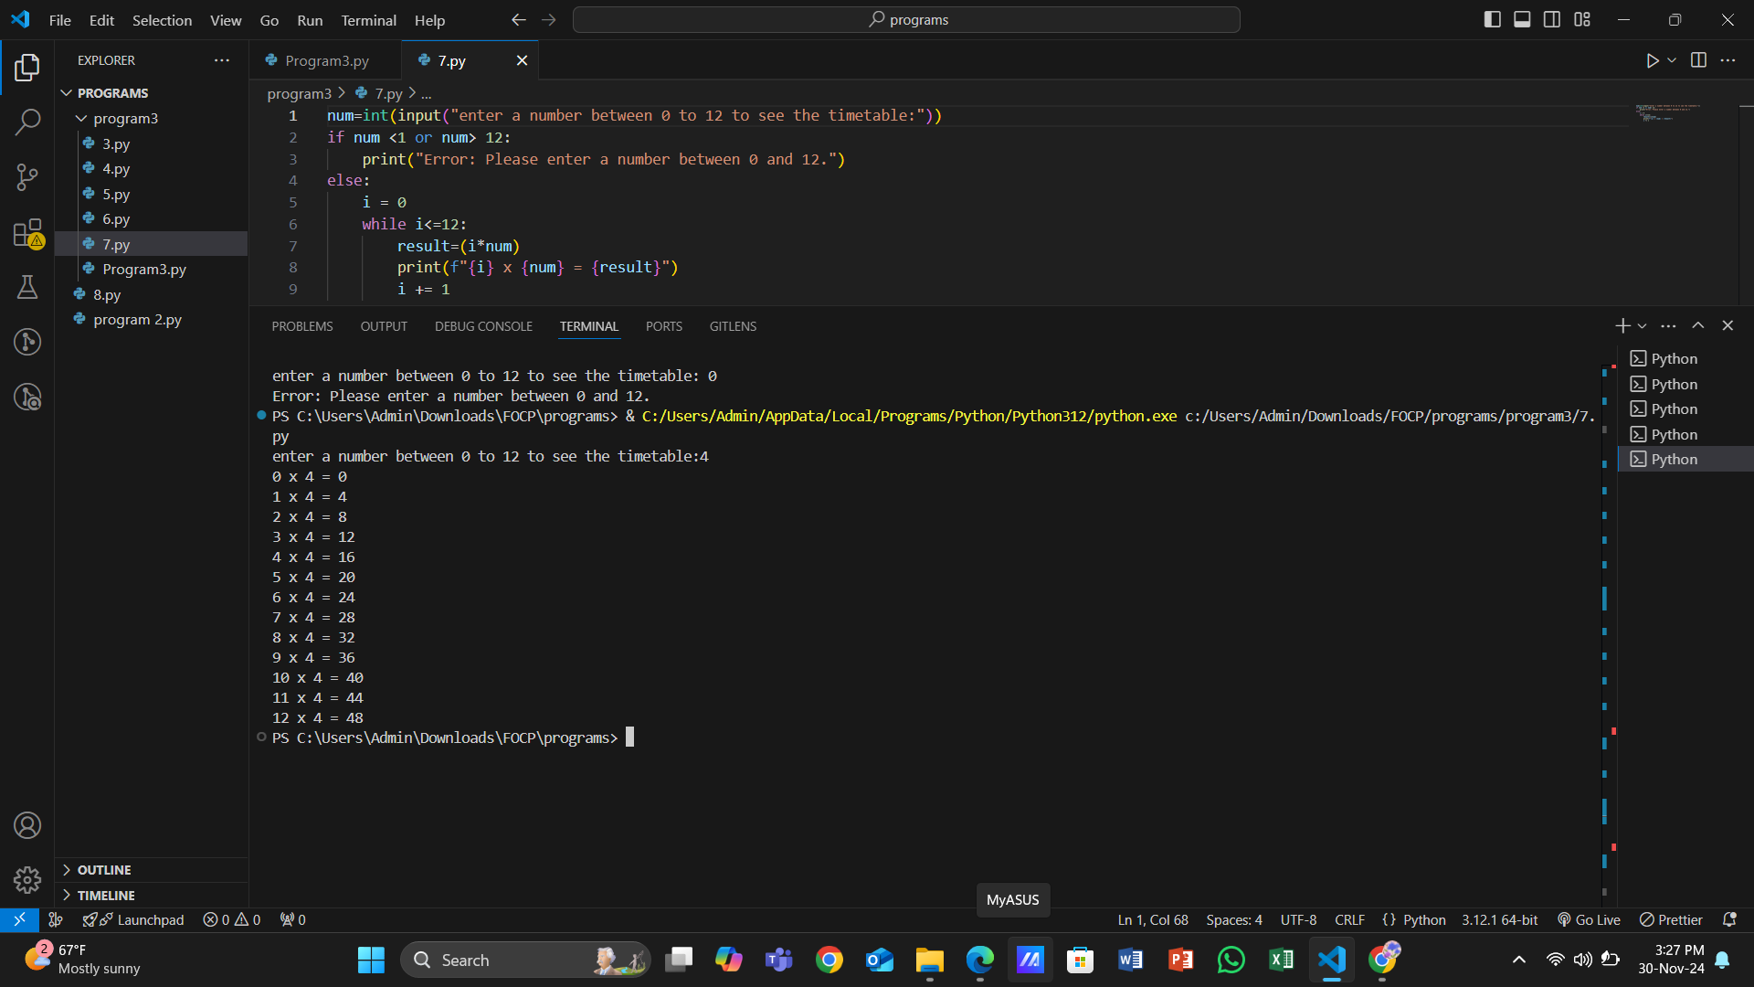

8. Modify the "Times Table" again so that the user still enters the number of the table, but if this number is negative the table is printed backwards. So entering "-7" would produce the Seven Times Table starting at "12 times" down to "0 times".

→ Here is the output

